**Summer Camp**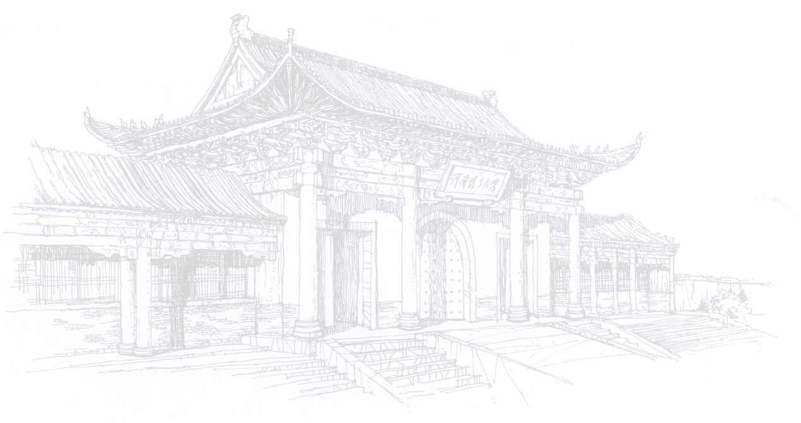

**Held by Henan Polytechnic University, China**

1. **Outline**

* **Time:** 10 days from 21st -30th June, 2025 (to be confirmed)
* **Location:** 2001 Century Road, Jiaozuo City, Henan Province, China
* **Main contents:** courses and activities including Chinese language, Taiji, calligraphy, cultural tours
* **Participants: 20** students in total from European sister universities of HPU; **1-2** participants for each university.

**2. Fees and Sponsorship**

HPU will cover the following expenses for every participant, including the accommodation, meals, local transportation and short-term accident insurance during their stay in the summer camp.

Participants are responsible for their own visa application fees, international airfare, travel insurance and other personal expenses, not limited to the above mentioned.

1. **Application**
2. **Deadline:** Please send us the information before **January 31, 2025**
3. **Online-interview.** HPU and the home university will organize an interview for the applicants in **early March.**

Attachment 1 Tentative Schedule

**Attachment 1**

**Tentative Schedule**

|  |  |  |
| --- | --- | --- |
| **Date** | **Time** | **Activity** |
| Day 1 | all day  (08:00~18:00) | Arrived in Beijing |
| Day 2 | daytime  (08:00~17:30) | Visit the Palace Museum in Beijing |
| evening  (17:36~22:30) | Beijing to Jiaozuo, Check-in |
| Day 3 | morning  (08:30~11:30) | Chinese Language 1 |
| afternoon  (15:00~18:00) | Learning the Eleven Essential Techniques of Chen’s Taijiquan |
| Day 4 | morning  (08:30~11:30) | Chinese Language 2 |
| afternoon  (15:00~18:00) | Taijiquan Lecture  Learning the Eleven Essential Techniques of Chen’s Taijiquan–Chenjiagou, Wen County in Jiaozuo |
| Day 5 | morning  (08:30~11:30) | Chinese Language 3 |
| afternoon  (15:00~18:00) | Learning the Eleven Essential Techniques of Chen’s Taijiquan |
| Day 6 | morning  (08:30~11:30) | Introduction to China  China Contemporary Water Conservancy Project Construction–Museum of South-to-North Water Diversion Project in Jiaozuo |
| afternoon  (15:00~18:00) | Introduction to China  China Economy, Technology, Ecological Civilization and Diplomacy Policy |
| Day 7 | morning  (09:00~11:00) | Chinese Calligraphy |
| afternoon  (15:00~18:00) | Introduction to The Yellow River Civilization Jiaying Temple in Jiaozuo |
| evening  (19:30~20:30) | Communication and Exchange Meeting with HPU students |
| Day 8 | all day  (09:00~17:00) | Visit the Chinese Character Museum in Anyang |
| Day 9 | all day  (09:00~17:00) | Visit the Diecai Cave Cultural and Educational Base & Global Geoparks |
| Day 10 | morning  (08:30~11:30) | Closing Ceremony |
| afternoon  (14:00~20:00) | Departure |